Ascent II
Learn the next step of the Bear Hunter System: Shoot, which refines your non-linear note-taking skills even further.
Overview and recommendations
Key dimensions | Deep processing, self-regulation
Recommended pace | Most learners see best results with 8 hours of theory across 3 to 4 weeks.
Recommended practice | Most learners see best results with 8 weeks of practice.
Progression tips | Ascent 2 has one of the highest practice-to-theory ratios of any stage, and minor errors in previous stages often become apparent in Ascent 2. You will likely spend the longest in this stage than any previous stage. Challenge yourself by applying the techniques to a wide range of learning needs. If you have sufficient competence with the previous stages, this stage should be a natural extension of your current methods, and you should also notice clear improvements in learning efficiency. If this is not the case, there is a high chance of technique error and we strongly recommend a skill audit to find errors before progressing.
How this stage helps you
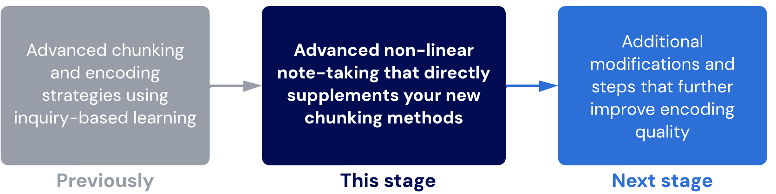

Lessons
- Bear Hunter System: Shoot
After we Aim, we Shoot. During this step, we deepen relationships and take our non-linear note-taking to the next level.
- Effective note-taking
Reach the next level of note-taking competence with the VPReFRE criteria.
Sub-lessons
- Effective note-taking: Visual
- Effective note-taking: Processed, relational, freehand
- Effective note-taking: Reflective
- Examples of note-taking
- Mind maps
This lesson extends from the previous with more guidelines and examples.
Sub-lessons
- Beginner’s mindmap guide
- Mindmap dissection
- Chunking by importance
- Shoot examples
Just like for Aim, we'll walk through various examples of Shoot for a range of topics.
Sub-lessons
- Biology 1
- Biology 2
- Chemistry
- Languages
- English - text response
- English – unfamiliar text
- Math
- Layers of learning
We introduce another of our core principles to unlock the next stage of efficiency: layers of learning.
- Barriers for shooting
We introduce some of the common barriers that can prevent success with learning the Shoot step.
- Final checkpoint – Ascent 2
You know the drill! It's time to practise and check your skill level before moving on.

  - Bear hunter system – shoot
Shoot
The Shoot step is the second part of the Bear Hunter System. It is an upgraded version of the green light step of TLS that you are used to. At this point, you can completely replace your TLS with using the Aim and Shoot steps.
Aim vs. Shoot
- During Aim, we prime our brain to find meaningful relationships by asking importance-based questions.
- During Shoot, we satiate that curiosity to clarify relationships, add detail, explore further relationships, make judgments on chunks and relationships, and focus on constructing our map.
Note that not every question has to be answered perfectly. Sometimes, you will ask questions that are so complex or advanced that it is not realistic to be able to answer them. The learning occurs when we attempt to answer it, which helps us to reinforce our relationships.
Finding Shoot easy?
Good! If you’ve aimed properly, shooting is easy.
Shooting becomes difficult when old bad habits or lower-order, linear learning interfere. Lower-order habits can cause us to have impaired order control. Using the non-linear note-taking system of Shoot will help to anchor your thoughts and keep them focused.
In this stage...
The following techniques are new.
New Technique | Rationale
Bear Hunter System – Shoot | A more effective form of note-taking. This step stacks together multiple previous skills into one.
The following are techniques from prior stages that you should continue using.
Techniques | Notes
Bear Hunter System – Aim
Maintaining Focus and BEDS-M | Start turning this into a habit
Scheduling Basics and SIR | Should be second-nature
The following techniques have been replaced and upgraded.
Prior Technique | Replaced by…
Traffic Light System – Green light | Bear Hunter System – Shoot
Notes and Processing* | Bear Hunter System – Shoot

  - Effective note-taking

Evidence-based note-taking
The science around note-taking is complicated. Here are some of the key principles of note-taking that we know from reviewing the latest research.
Key principles of note-taking
- The method we use to take notes matters less than how we are thinking as we take notes.
- Good note-taking can help our brain think by reducing unhelpful and extraneous cognitive load.
- Bad note-taking can make us avoid thinking, which reduces the effectiveness of learning.
- Wordier notes are usually less processed and therefore less effective. Typing can exacerbate this as it is usually easier to create high volumes of notes compared to freehand writing.
In the sublessons below, we will explore some of these principles in much greater depth to see how you can refine your note-taking technique.
Sublesson
- Effective note-taking: Visual
- Effective note-taking: Processed, relational, freehand
- Effective note-taking: Reflective
- Examples of note-taking

- Effective note-taking: visual
V for Visual
The first letter, V, stands for Visual. Here, you reduce the amount of words and use more visuals – pictures, symbols, doodles, shorthand and diagrams.
Using visuals greatly helps with retention as it incorporates multiple modes of learning. Visuals act as landmarks in your memory. It also makes your notes fun and personal!
Key principle
As with all note-taking, what you produce is less important than the processes you used to produce it.
Even though other people probably won’t understand your doodles, you will have a deep and meaningful connection to them because you went through the cognitive process of imagining and creating them.
About learning styles
Belief in Learning Styles May Be Detrimental.
The Learning Styles Myth
More references on learning styles and multimodal learning
Conyers M, Wilson D. Believing in the Brain. Educational Leadership [Internet]. 2020 May [cited 2020 Jun 8];77(8):1–6.
Deale CS. Learning Preferences Instead of Learning Styles: A Case Study of Hospitality Management Students’ Perceptions of How They Learn Best and Implications for Teaching and Learning. International Journal for the Scholarship of Teaching & Learning [Internet]. 2019 Jul [cited 2020 Jun 8];13(2):1–7. doi: 10.20429/ijsotl.2019.130211
Kraemer DJ, Rosenberg LM, Thompson-Schill SL. The neural correlates of visual and verbal cognitive styles. J Neurosci. 2009;29(12):3792‐3798. doi:10.1523/JNEUROSCI.4635-08.2009. doi: 10.1523/JNEUROSCI.4635-08.2009
Moussa-Inaty J, Atallah F, Causapin M. Instructional Mode: A Better Predictor of Performance Than Student Preferred Learning Styles. International Journal of Instruction [Internet]. 2019 Jul [cited 2020 Jun 8];12(3):17–34. doi: 10.29333/iji.2019.1232a
Nancekivell SE, Shah P, Gelman SA. Maybe They’re Born With It, or Maybe It’s Experience: Toward a Deeper Understanding of the Learning Style Myth. Journal of Educational Psychology [Internet]. 2020 Feb [cited 2020 Jun 8];112(2):221–35. doi: 10.1037/edu0000366
Tovar-Moll F, Lent R. The various forms of neuroplasticity: Biological bases of learning and teaching. Prospects (00331538) [Internet]. 2016 Jun [cited 2020 Jun 8];46(2):199–213. doi: 10.1007/s11125-017-9388-7
Lesson correction: The hemispheric myth
The video above may contain some premature assumptions that do not reflect the most recent research. Please read below.
The idea that the brain has different hemispheres with fixed specific functions is now under contention.
What we know:
- Different parts of the brain have different functions, as demonstrated through a large volume of brain imaging studies.
- Hemispheres seem to have no relationship to personality.
- People do not seem to have one hemisphere that is dominant at a cognitive level for information processing, though dominance for sensory and motor function is well established.
- Different areas of the brain seem to be discretely activated for different functions, and a general preference for one hemisphere over the other has been demonstrated. However, recent findings also show other parts of the brain being activated for certain forms of information that are not consistent with the existing theory.
- Teaching to include multimodal learning is supported by evidence. However, there is insufficient evidence to suggest that this benefit is due to the differential usage of hemispheres rather than cortices.
Based on the current level of research, the argument made in this video that the dominant hemisphere is responsible for more rational thinking while the non-dominant hemisphere is responsible for abstract thinking may be contended as there is insufficient evidence to make this conclusion. While motor and sensory dominance has been consistently demonstrated, this is not necessarily the same as information-processing dominance or limited to strict hemispheres.
While this is theoretically valid to explore, it may not practically matter if hemispheric dominance is true or not since incorporating multimodal learning has been shown to have a benefit, regardless of why.
- Effective note-taking – processed, relational, freehand
Processed
The next letter in the acronym, P, stands for Processed.
You must process the information somehow – we want to process it as a problem by asking questions. Again, visuals will also help you to process information.
Relational
“Re” stands for Relational. Do not focus on remembering individual pieces of information; always relate it to other information. If you read linearly, your brain does not process the information as effectively, and any information that goes in will quickly go out. That is why retention dramatically increases when you focus on strengthening the relationships between pieces of information. We do this by using mind maps.
Freehand
“F” stands for Freehand. Typing is too single-minded and doesn’t encourage much thinking. Freehand writing forces us to process the information more. It also allows us to represent things more visually, whereas typed documents don’t represent relationships well.

App and device recommendations for digital note-taking
A good note-taking app has the following features:
- Facilitates the correct cognitive processes for learning based on modern research (most important)
- Has good organizational features for multiple notes (less important)
To facilitate the correct cognitive processes, a note-taking app should have an infinite canvas and allow for convenient, fast freehand drawing with a digital stylus. Since most note-taking apps were designed based on what would sell best rather than actual learning research, many of them are restrictive to efficient learning.
We have independently reviewed and tested all of these apps under a variety of circumstances.
The following apps are well-known but inefficient:
Evernote: Has leading levels of note organization but a horrible and linear note-taking experience, which is extremely restrictive.
Notion: Has high levels of note organization and lots of note-taking options, but all of the options are linear. For this reason, Notion is extremely limited and not recommended for efficient or effective note-taking.
The following apps are well-known and reasonable:
Notability: Has decent note organization and a good writing experience, but is severely limited by its lack of infinite canvas.
OneNote: Has good note organization and a somewhat infinite canvas, but the canvas is limited by its low level of zoom-out, which eventually causes notes to become very difficult to read. The writing experience is also average, with no palm detection or pressure sensitivity (two small but meaningful features that make your note-taking more immersive).
The following apps are recommended:
Freeform for iOS: Comes bundled as part of iOS and is therefore "free" (if you purchase an iPad). Works well but lacks some of the aesthetic functionalities that Concepts has. Recommended app for those on iOS and on a budget.
Concepts: Was originally an app for design and architecture. Concepts is overloaded with features you will never use, but it has an excellent writing experience with full infinite canvas and acceptable note-organization features.
Squid: One of the best (and most underrated) note-taking apps on the market. Excellent, intuitive, simple writing experience and good note organization alongside infinite canvas. Not overloaded with features like Concepts.
Leonardo x OneNote or Evernote for Windows: Windows does not have any good note-taking apps, but Leonardo is the best alternative. It is a fully-featured drawing app with infinite canvas, but it has no inbuilt organization. You simply save project files and can export drawings as images or PDFs. Its lack of organization can be overcome by exporting these files and importing them into something like Evernote or Onenote.
Explain Everything: An app created for online teachers and instructors. We use this app to record all of our tablet videos. It is fully featured with great organization features but is more expensive.

Basic references for the advantages of freehand
At a technical level, there are several different studies and findings that support freehand expression. As a summary:
Freehand note-taking increases deep processing by facilitating higher cognitive load, improving focus (potentially due to increased anchoring), and providing more opportunities for visual or abstract expression.
One of the most famous studies on this is The Pen is Mightier Than the Keyboard by Oppenheimer. However, his study does not conclusively explain why freehand offers these advantages. Cognitive load theory and multimodal learning theory provide a more robust explanation.

References for the power of freehand expression combined with visualisation
Fuson KC. Relating Math Words, Visual Images, and Math Symbols for Understanding and Competence. International Journal of Disability, Development & Education [Internet]. 2019 Mar [cited 2020 Jun 9];66(2):119–32. doi: 10.1080/1034912X.2018.1535109
Jaeger AJ, Velazquez MN, Dawdanow A, Shipley TF. Sketching and Summarizing to Reduce Memory for Seductive Details in Science Text. Journal of Educational Psychology [Internet]. 2018 Oct [cited 2020 Jun 9];110(7):899–916. doi: 10.1037/edu0000254
Kantrowitz A, Fava M, Brew A. Drawing Together Research and Pedagogy. Art Education [Internet]. 2017 May [cited 2020 Jun 9];70(3):50–60. doi: 10.1080/00043125.2017.1286863
Schwamborn A, Thillmann H, Leutner D, Mayer RE, Leopold C. Drawing as a Generative Activity and Drawing as a Prognostic Activity. Journal of Educational Psychology [Internet]. 2010 Nov [cited 2020 Jun 9];102(4):872–9. doi: 10.1037/a0019640
Sun L, Xiang W, Yang C, Yang Z, Lou Y. The Role of Sketching States in the Stimulation of Idea Generation: An Eye Movement Study. Creativity Research Journal [Internet]. 2014 Jul [cited 2020 Jun 9];26(3):305–13. doi: 10.1080/10400419.2014.929413
Tadayon M, Afhami R. Doodling Effects on Junior High School Students’ Learning. International Journal of Art & Design Education [Internet]. 2017 Feb [cited 2020 Jun 9];36(1):118–25. doi: 10.1111/jade.12081
Wammes JD, Jonker TR, Fernandes MA. Drawing improves memory: The importance of multimodal encoding context. Cognition [Internet]. 2019 Oct [cited 2020 Jun 9];191:N.PAG. doi: 10.1016/j.cognition.2019.04.024
Wu SPW, Rau MA. How Students Learn Content in Science, Technology, Engineering, and Mathematics (STEM) Through Drawing Activities. Educational Psychology Review [Internet]. 2019 Mar [cited 2020 Jun 9];31(1):87–120. doi: 10.1007/s10648-019-09467-3

iii. Effective note-taking – reflective
Reflective
“R” stands for Reflective. You need to take time to reflect on your notes and check that they are not in the same order as the resource (e.g. textbook). We are used to working in order from start to finish, but this is not how our brain learns. To avoid falling into bad habits, reflect to see if your notes are in an order that makes sense to your brain (not linear).
Efficient
“E” stands for Efficient and is a check for understanding. You have to ask yourself if your note-taking is allowing you to learn a lot within the amount of study time.
Are you forgetting more than 30% of the information you are writing in your notes? If you are, there is something wrong with how you are doing the previous points of VPReFRE.
Key principle
Effective note-taking should help our brain learn, not help it avoid learning.
This final check is to make sure you are retaining the information and can use and apply it. If you can’t, something in your note-taking process needs to be changed.

  - Examples of note-taking
Good note-taking will satisfy VPReFRE – Visual, Processed, Relational, Freehand, Reflective and Efficient. If your mind map is done correctly, it will satisfy this checklist.
We will look at a variety of examples and show you why the notes are good or very bad. You might be shocked to see that common (even typically applauded) note-taking methods are very ineffective for learning.
We will also show you how traditional notes can be improved so you can retain, recall and apply more information.
- Mind maps
In the sublessons below, we'll go even deeper with note-taking with more examples and guidelines.
Sub-lessons
- Beginner’s mindmap guide
- Mindmap dissection
- Chunking by importance

  - Beginner’s mindmap guide
Art of mapping
By now, you've probably realised that creating mind maps is a surprisingly technical skill.
Below, we'll summarise some of the biggest steps as a general refresher of the process. Then we will explore some additional examples and dissections.
Creating a good mindmap: An overview
- Identify the biggest chunks. These will be hypothetical at first. There are usually 3 to 7 for a single topic.
- Arrange the chunks and most important contained concepts so that the relationship and flow between them is expressed.
- Identify sub-concepts and sub-chunks and add them to the map. Always think about how each new chunk or concept fits into the big picture.
- Add more details until the topic is complete. Information that is highly specific and not related to other parts on the map can be added to memorisation techniques such as flashcards.
General tips
- When arranging your first chunks, leave big spaces between them so there is room for sub-chunks and other concepts.
- Make the main flow of relationships between the largest chunks visually very clear. This is the "backbone" of the topic.
- Remember to relate each new item to the bigger picture as you go.
- Constantly refine and revise your structure. Do not overly commit to your first chunk structure. Everything is just a hypothesis!
Missing something?
If you spot a part of the process that you were neglected or skipping, attempt a mindmap following the guidelines above before moving on.

  - Mindmap dissection
Learning happens in the brain 🧠
Simply completing a mindmap does not make your learning effective. If misused, mind maps can be just as bad as other types of notes. What's important is to use the right cognitive process so that mindmapping helps your brain think.
You know you are mindmapping correctly when you...
- Find it easier to think of new relationships and chunks by seeing what you have already written down
- Are able to reflect on how each individual piece connects to the big picture
- Find that it feels messy and confusing at first, but over time as the mindmap becomes more organised and accurate, your knowledge also feels more organised and accurate
- Continuously refine and update your mindmap (which indicates that you are constantly thinking of the big picture, holding yourself to a high standard, and keeping structures hypothetical)
- Constantly engage in higher-order thinking processes (analysing by finding similarities and differences and evaluating by prioritising and making value judgments)
Having trouble?
Remember to ask for feedback in our community. Our coaching staff are also always around to assist you.

References on the efficacy of mindmaps
Adam A, Mowers H. Get Inside Their Heads with Mind Mapping. School Library Journal [Internet]. 2007 Sep [cited 2020 Jun 9];53(9):24.
Amin M, Hina QA. Effect of Mind Mapping Technique on Student Intrinsic Motivation at Higher Education Level. Journal of Research & Reflections in Education (JRRE) [Internet]. 2018 Dec [cited 2020 Jun 9];12(2):296–313.
Astriani D, Susilo H, Suwono H, Lukiati B, Purnomo AR. Mind Mapping in Learning Models: A Tool to Improve Student Metacognitive Skills. International Journal of Emerging Technologies in Learning [Internet]. 2020 Jun [cited 2020 Jun 9];15(6):4–17. doi: 10.3991/ijet.v15i06.12657
Fu Q-K, Lin C-J, Hwang G-J, Zhang L. Impacts of a mind mapping-based contextual gaming approach on EFL students’ writing performance, learning perceptions and generative uses in an English course. Computers & Education [Internet]. 2019 Aug [cited 2020 Jun 9];137:59–77. doi: 10.1016/j.compedu.2019.04.005
Gargouri C, Naatus MK. An experiment in mind-mapping and argument-mapping: Tools for assessing outcomes in the business curriculum. E-Journal of Business Education & Scholarship of Teaching [Internet]. 2017 Jul [cited 2020 Jun 9];11(2):39–78.
HARIYADI S, COREBIMA AD, ZUBAIDAH S, IBROHIM. Contribution of Mind Mapping, Summarizing, and Questioning in the RQA Learning Model to Genetic Learning Outcomes. Journal of Turkish Science Education (TUSED) [Internet]. 2018 Mar [cited 2020 Jun 9];15(1):80–8. doi: 10.12973/tused.10222a
Jun Luo. Teaching Mode of Thinking Development Learning Based on Mind Mapping in the Course of Health Fitness Education. International Journal of Emerging Technologies in Learning [Internet]. 2019 Aug [cited 2020 Jun 9];14(8):192–205. doi: 10.3991/ijet.v14i08.10110
Kenny J. Mind-mapping: Cortical clobber. TES: Times Educational Supplement [Internet]. 2004 Jun 18 [cited 2020 Jun 9];(4588):29.
Kenny J. Mind-mapping: It’s totally mental. TES: Times Educational Supplement [Internet]. 2004 Jun 18 [cited 2020 Jun 9];(4588):28–9.
MASNAINI, COPRIADY J, OSMAN K. Cooperative integrated reading and composition (CIRC) with mind mapping strategy and its effects on chemistry achievement and motivation. Asia-Pacific Forum on Science Learning & Teaching [Internet]. 2018 Jun [cited 2020 Jun 9];19(1):1–18.
Santiago HC. Visual Mapping to Enhance Learning and Critical Thinking Skills. Optometric Education [Internet]. 2011 Summer [cited 2020 Jun 9];36(3):125–39.
Stokhof H, de Vries B, Bastiaens T, Martens R. Mind Map Our Way into Effective Student Questioning: a Principle-Based Scenario. Research in Science Education [Internet]. 2019 Apr [cited 2020 Jun 9];49(2):347–69. doi: 10.1007/s11165-017-9625-3
Tsinakos AA, Balafoutis T. A Comparative Survey on Mind Mapping Tools. Turkish Online Journal of Distance Education (TOJDE) [Internet]. 2009 Jul [cited 2020 Jun 9];10(3):55–67.
Vijayavalsalan B. Mind Mapping as a Strategy for Enhancing Essay Writing Skills. New Educational Review [Internet]. 2016 Jul [cited 2020 Jun 9];45(3):137–50. doi: 10.15804/tner.2016.45.3.11

  - Chunking by importance
Evaluating importance
By now, you realise that there are many ways to chunk. The critical part of learning that drives efficiency is to engage in evaluate where the value of those chunks is judged and critiqued. This is where chunking by importance comes into play.
Example
Consider a topic around cellular biology. Read the below sample excerpt on how the topic is presented and think about how you might chunk this topic.

Sample textbook excerpt
Title: Types and Arrangements of Epithelial Cells
Cell Types
- Squamous Cells
  - Description: Flat, scale-like cells.
  - Function: Efficient diffusion and protection in stratified squamous epithelia (e.g., skin, oral cavity).
- Cuboidal Cells
  - Description: Cube-shaped cells.
  - Function: Secretion and absorption in simple cuboidal epithelia (e.g., kidney tubules, gland ducts).
- Columnar Cells
  - Description: Tall and slender cells.
  - Function: Nutrient absorption and secretion in simple columnar epithelia (e.g., digestive tract).
Cell Arrangements
- Stratified Epithelium
  - Description: Multiple layers of cells.
  - Function: Provides strength and protection, e.g., stratified squamous epithelium in the skin.
- Simple Epithelium
  - Description: Single layer of cells.
  - Function: Facilitates diffusion, secretion, and absorption. Found in simple cuboidal and simple columnar epithelia.
- Pseudostratified Epithelium
  - Description: Appears stratified but isn't.
  - Function: Moves mucus and particles in the respiratory tract for protection (e.g., pseudostratified columnar epithelium).
Important Epithelial Cell Linings
- Stratified Squamous Epithelium
  - Function: Provides protection against abrasion and pathogens (e.g., skin, oral cavity).
- Simple Cuboidal Epithelium
  - Function: Regulates urine composition through secretion and absorption (e.g., renal tubules).
- Simple Columnar Epithelium
  - Function: Facilitates nutrient absorption and secretion of digestive enzymes (e.g., digestive tract).
- Pseudostratified Columnar Epithelium
  - Function: Moves mucus and particles to protect the respiratory system (e.g., respiratory tract).
You might decide that rather than trying to memorise the functions of each important cell lining, we can chunk them into types vs. arrangements, since the important linings are simply examples of different combinations of types and arrangements.
Expand the accordion below to see the mindmap that is created by following this process and noting the functions that extend from each combination.
Initial mindmap attempt
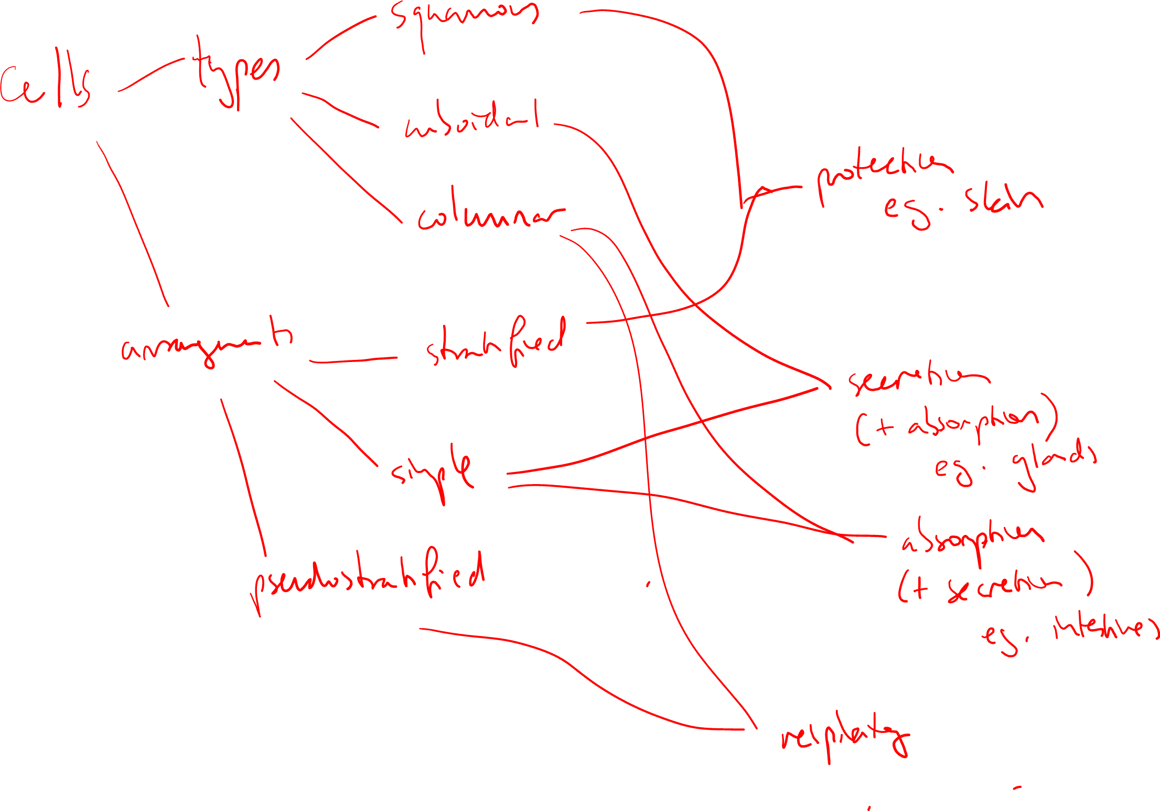Notice the slight spiderwebbing where there are multiple relationships between multiple concepts that look messy and hard to follow.

Alternative mindmap
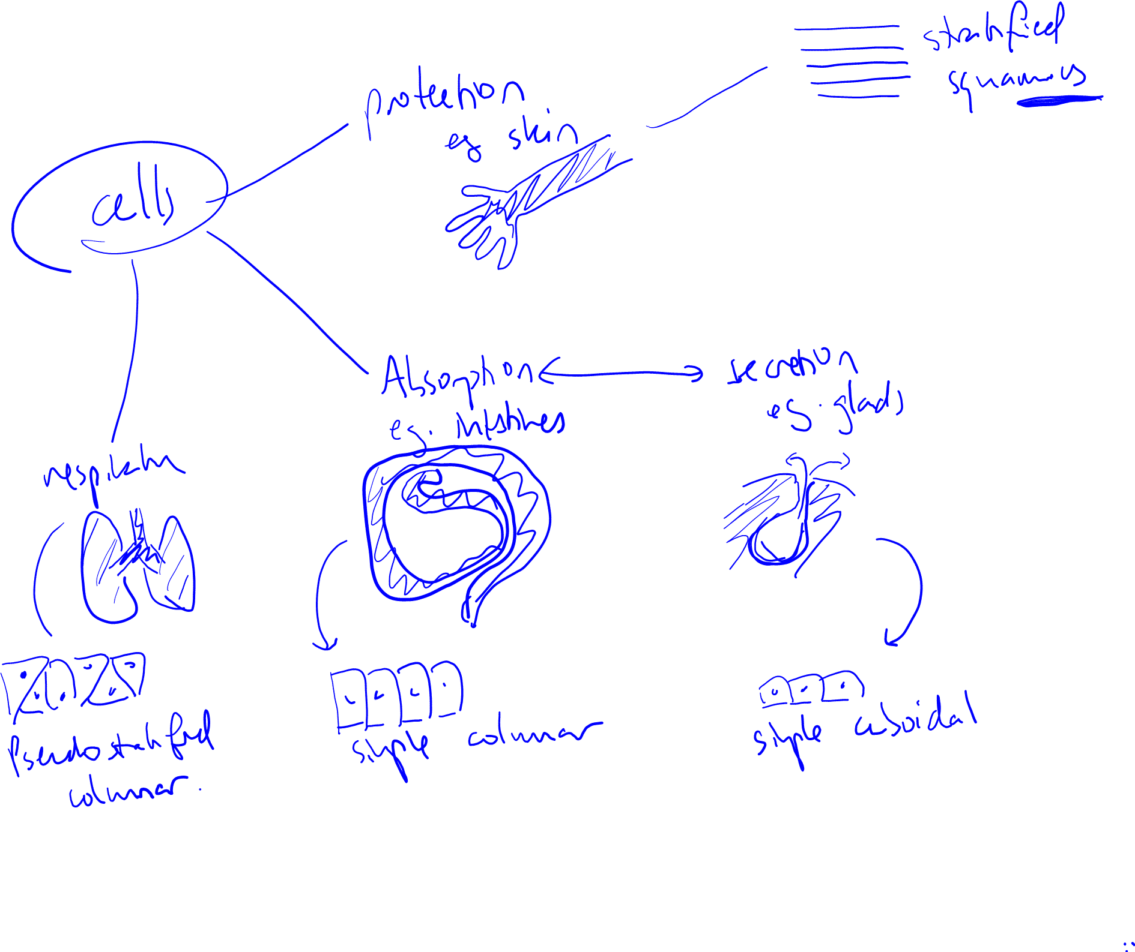Notice it is clearer and easier to follow and much more intuitive.
By chunking it differently, we emphasise different relationships. This decision is made based on what makes the topic more memorable, more intuitive, and less overwhelming. For most learners, simpler means better and the first attempt at creating a chunk structure is almost never the simplest it can be.
Key principle
Often, the best chunk structure comes from seeing the topic from a different perspective to how it was originally taught. There must be an active effort and willingness to consider other ways of chunking. Almost always, finding a perspective of chunking that you have not found before will feel difficult or even impossible. Try anyway.
As a general rule, always assume that there is a missing perspective or simpler way. Make it your job to find it. Yes, it is difficult. Yes, you must still find it!
Those who push themselves to this standard will unlock a rare level of knowledge mastery and learning efficiency that is seen only in the top learners of the world.
In this instance, the function came first; however, chunking by function is not always best. For example, in Chemistry, “function” is not the reason why some functional groups or reactions are important. It could instead be due to them having similar reaction mechanisms or reactivity. In English, importance could be assigned to the author’s perspective or elements of their background and worldview.
This is why the question is "Why is it important?" and not “What are their shared functions?”
The standard for importance
Many learners struggle to find the most meaningful and important chunks for a topic. In many cases, the question of "why is it important" was not explored fully and to a sufficient standard.
We can think about this as finding immediate reasons vs. root reasons.
Immediate vs. root reasons
A root cause is the fundamental reason something happens. Similarly, a root reason could be considered the fundamental reason for something to be important. This can be illustrated by a story from the famous marketer, Seth Godin, who explains why people are motivated to buy things.
Godin asked why people buy drill bits (the metal things on the end of drills to make holes).

The immediate answer could be that they want to make a hole in the wall. But this is not the root reason.
People don't want a hole in the wall. They want the screw that will go inside the hole. But this is still not the root. They don't just want the screw; they want the picture that will hang on it. And they don't just want the picture; they want the feeling they will get from looking at the picture on the wall.
In this case, the root reason is that people buy drill bits to feel good when they see a picture on the wall.
Root reasons in learning
Similarly, in learning, the root reason something is important is sometimes not immediately obvious.
For example, when studying about genetic diversity (the variety of genes and genetic characteristics within a population or a species), learners may conclude that genetic diversity is important because it leads to variation.

However, if we ask, "why is variation important?", we can arrive at a root reason that variation is essential for the adaptability, resilience, and long-term survival of species and ecosystems.
Therefore, instead of creating a chunk called "variation", we may create one called "survival" instead. Notice how the second chunk is much broader and can likely encompass many more sub-concepts or sub-chunks. It will probably also be easier to create relationships to and from.
The "So what?" approach
Some people use the "So what?" approach where every time we find a reason for importance, we then ask "So what?" until the question no longer makes sense to ask. At this point, we have presumably found the root reason.
- Shoot examples
In the sublessons below, we demonstrate the usage of the Shoot step across a variety of subjects. Even if your particular discipline is not included as an example, the methods of thinking are completely transferrable.
You can skip sub-lessons you are not interested in by marking them as complete. However, we recommend watching several different examples to get a clear understanding of the technique.
Aim-Shoot cycling
Once you have proficiency with Aim and Shoot as individual steps, you can (and maybe already have without any instruction) start transitioning between Aim and Shoot seamlessly in a continuous cycle. Watch the video below to see this in action. You will see the results of this process in each of the subject-specific examples.
Struggling with Aim-Shoot cycling?
Don't worry. Keep practising, and you should naturally feel like you can do it. Aim-Shoot cycling is often something that develops as a result of upper conscious competence in each individual step.
Sub-lessons
- Biology 1
- Biology 2
- Chemistry
- Languages
- English - text response
- English – unfamiliar text
- Math

- Layers of learning
Four layers of learning
“Layers of learning” focuses on implementing a structure when learning information.
Key principles
- Always start from the logic layer and work out towards the later layers.
- The logic and concepts layers remain hypothetical and can be refined and adjusted at any point of the learning process.
- Most information resources are not divided into optimal layers. Usually, detail comes far too early.
- Order control allows us to rearrange the order in which our brain consumes and organizes information; layers of learning tell us how to rearrange it.
Alert
Layers of learning is one of our program's core pillar concepts.
Overview of each layer
Expand the accordions below to read an overview and description for each layer.

Logic
The first and innermost layer is logic. You start with the “backbone” of information, finding the big-picture purpose of what you are learning. This backbone is made up of the largest concepts, chunks, and most important relationships.
We build these relationships by asking, “Why is it important?” and “How does it relate?” and seeing how everything logically connects together.
People often skip this step entirely – this is like rushing to build a house and neglecting the foundation.

Concepts
The second layer is the concepts. These are the main details and ideas that make up the bulk of subject-specific understanding.
The concept layer builds upon the first layer by taking all of those big ideas and asking, “How does it happen?” and “What is it?”.
Students who ignore the first layer will often struggle with learning the concepts

Details (important)
The third layer is the important details.
Details are specific information that often needs to be rote-learned and memorized. However, some details will be important because they help you understand the concepts, while others may just be arbitrary. Important details allow abstract concepts to be understood more concretely.
You can identify the important details by asking, “Does knowing this detail help me understand the concept it is attached to?” If the answer is yes, it’s important. If the answer is no, it’s arbitrary!
Details (arbitrary)
The fourth and outermost layer is the arbitrary details. These are disconnected pieces of information that may seem random or unnecessary but are still in the curriculum or exam.
We only learn these details because we need them for assessments. They must be rote-learned, at least until one day when we have learned far more, and they naturally make sense.
When we look at the total volume of information we need to study, only about 10% is conceptual, and about 20% is important details. This means the remaining 70% is arbitrary details. So, if you just study from beginning to end, you will not be able to retain much of the information because most of it is arbitrary and unconnected! You will find yourself trying to remember a lot of information that doesn’t have any significance or meaning.
Conversely, if you start with deep, foundational information, this will dramatically increase your overall studying speed because by increasing the relevance of information, it turns arbitrary details into relevant details!

Key principle
Layers are not static. How relevant a detail is depends on whether we have the structure to give it relevance. This means that errors in building an importance-based logic and concepts layer often mean we have more seemingly irrelevant details. The trick to reducing layer 4 (arbitrary details) is to improve layers 1 and 2.
Even if a tree has 10,000 leaves, it may only have 5 or 6 main branches. Spending time on the branches allows the leaves to arise more naturally.
As a general guide, it is usually best to overinvest in developing clear layers 1 and 2, as this makes a dramatic difference to the time it takes to cover layers 3 and 4, where the majority of time can sometimes be wasted.
Layering and cognitive load
Learning in layers is one of the most powerful principles you can integrate into your learning system. It makes large volumes of content less overwhelming and more relevant, improves retention, and creates deeper mastery. One of the reasons for this is that learning in layers optimises your cognitive load.
Read our in-depth article here on how layering and "scaffolding" improve learning.
The value of theory
Understanding how layering improves learning at a theoretical level helps you self-diagnose and adapt your learning if it isn't as effective as you want it to be. This helps you to coach yourself when you face new challenges, which is an essential part of self-regulated learning!

Quiz: Layers of learning quiz
Question 1
Regarding learning in layers, select the most correct statement below:
The first layer we focus on is the logic layer.
The first layer we focus on is the concepts layer.
The first layer we focus on is the important details layer.
The first layer we focus on is the arbitrary details layer.
Ans: The first layer we focus on is the logic layer.
Regarding learning in layers, select the most correct statement below:
In the logic layer, we identify all the concepts that are part of the topic.
In the logic layer, we identify the largest headings in our learning materials.
In the logic layer, we identify the largest chunks and most important relationships.
In the logic layer, we identify the most difficult facts and concepts that are the hardest to understand.
Ans: In the logic layer, we identify the largest chunks and most important relationships.
Regarding learning in layers, select the most correct statement below:
To identify these, we have to skim the material for the main headings.
To identify these, we have to understand each of the concepts in a high level of depth.
To identify these, we have to find similarities and differences between concepts to find chunks.
To identify these, we have to analyse and evaluate information to find similarities and judge the importance of them in relation to the big picture.
Ans: To identify these, we have to analyse and evaluate information to find similarities and judge the importance of them in relation to the big picture.
Question 2
Regarding the logic layer, select the most correct statement below:
Once we have found the logic layer, we can consider this layer complete. We then build on this with the concepts layer.
Once we have found the logic layer, we then build on this with the concepts layer. At any time, the logic layer can be changed to reflect our updated understanding.
Once we have found the logic layer, we then build on this with the concepts layer. The logic layer can be changed to reflect our updated understanding until we move into the details layer.
Once we have found the logic layer, we then build on this by adding more details.
Ans: Once we have found the logic layer, we then build on this with the concepts layer. At any time, the logic layer can be changed to reflect our updated understanding.
Question 3
Regarding your overall learning system, select the most correct statement below:
Layers of learning replaces the Aim-Shoot cycle.
Layers of learning provides a clearer target for our order control and inquiry.
Layers of learning provides a framework for implementing Kolb's.
Understanding about layers of learning increases our conscious competence with non-linear note-taking.
Ans: Layers of learning provides a clearer target for our order control and inquiry.
Regarding your overall learning system, select the most correct statement below:
The type of information we add into memorisation techniques such as flashcards falls into the details layers (3 and 4).
The type of information we add into memorisation techniques such as flashcards falls into the logic layer.
The type of information we add into memorisation techniques such as flashcards falls into the concepts layer.
The type of information we add into memorisation techniques such as flashcards are the types of information that do not fall into any of the layers.
Ans: The type of information we add into memorisation techniques such as flashcards falls into the details layers (3 and 4).
Regarding your overall learning system, select the most correct statement below:
The Aim-Shoot cycle is mostly useful for identifying the logic layer.
The Aim-Shoot cycle is mostly useful for identifying the concepts layer.
The Aim-Shoot cycle is mostly useful for identifying the logic and concepts layers.
The Aim-Shoot cycle is useful for identifying all layers.
Ans: The Aim-Shoot cycle is useful for identifying all layers.

- Barriers for shooting
Beware of barriers
Be careful of the following barriers to shooting. These are mistakes that students have made in the past, which prevented them from successfully taking on these techniques.
Which barriers resonate with you?
Aim-Shoot takes too much time!
The time spent building your mind map will create more connections in your brain and ultimately save you more time. The real waste of time is returning to traditional forms of learning, where you memorise pages of text with no escape (deathly spiral warning!). Also, building mind maps becomes much faster as you become more proficient at the technique, which makes learning even quicker over time.
We recommend reviewing our article here on how to accurately measure your learning efficiency to see if it really does take too long or if it just seems that way.

Aim-Shoot is too difficult!
Learners can become apprehensive of this technique because they cannot gain certainty about their knowledge for a long time.
However, the certainty that comes from traditional methods is actually an illusion of learning that does not reflect the knowledge you build mentally. This results in inconsistent performance and results, which lead to frustration, demotivation, and performance anxiety.
Remember that making and finding mistakes is a critical part of learning and improving. Students who do not find it difficult cause alarm bells to ring because it usually means they are not applying the technique to the correct standard!

What if I miss something?
You will miss more things by not using a mind map and following the layers. Mind maps structure your learning to match how your brain learns, which is ultimately the most optimal way to learn. You also don’t have to worry about missing details as you jump around and use order control because using the full Bear Hunter System with SIR will prevent any gaps.

- Final checkpoint – Ascent 2
Checkpoint tasks
Complete the recommended tasks below before moving on to the competence assessment and checklist below.
Recommended tasks
Add tasks to your focus list so you can practice the skills.
Dimensions
Ascent II
Complete an Ascent II level challenge week
Complete a challenge week by applying all of the methods you have learned so far. Make sure to incorporate:
  - Aim-Shoot cycling on different topics
  - Appropriate layers of learning identified via order control during the Aim-Shoot cycle
  - Multi-order interleaved retrieval practice
  - Appropriate time management and prioritisation
  - Appropriate focus and attention management
  - Kolb's at least 3 times during the week with cycling of experiments into subsequent Kolb's cycles
Complete this task once you have completed your challenge week.
Dimensions
Ascent II
Complete a skill audit
Using the checkpoints and meta-checklists so far, complete a skills audit on your current skill level and learning system. Implement any findings as experiments into your next Kolb's cycle.
Complete this task once you have completed your skill audit.

General competence assessment
Technique(s) | Level of Competency
Bear Hunter System – Shoot | You can connect the aim and shoot steps accurately and seamlessly, with high levels of chunking and accurate relationships between chunks. The amount of effort required to do this step should be moderately low.
Focus, Scheduling, BEDS-M and Revision | These should now have become a habit. You have achieved mastery (unconscious competence) in these basic skills.
Ascent II checkpoint items
To move on, you must have around 80% competence with the skills taught so far. Use the list below to check whether you're ready!
- You have replaced TLS with Aim-Shoot cycling and can do this with a reasonable accuracy, consistency and some reduction in effort.
- Your inquiry process consistently leads to meaningful and high-quality relationships.
- You are able to form importance-based chunks at the root reason level at least 70% of the time.
- You are able to represent the layers of learning clearly in your non-linear note-taking.
- You are able to express the main relationships and chunk structures in non-linear note-taking easily.
- Writing non-linear notes is comfortable and at the level of unconscious competence.
- You are able to do consistent Kolb's to a high quality and regularly.
- You are able to perform multi-order interleaved retrieval with high levels of competence and confidence.
- You are able to manage your time, priorities, focus, and attention effectively.

Quiz: Ascent 2 checkpoint quiz
Spot the issues!
In the following quiz, we will show you some work submitted by real students. Each case has a common mistake for you to learn from. Sometimes, you will learn about certain mistakes for the first time from these checkpoint quizzes!
Question 1
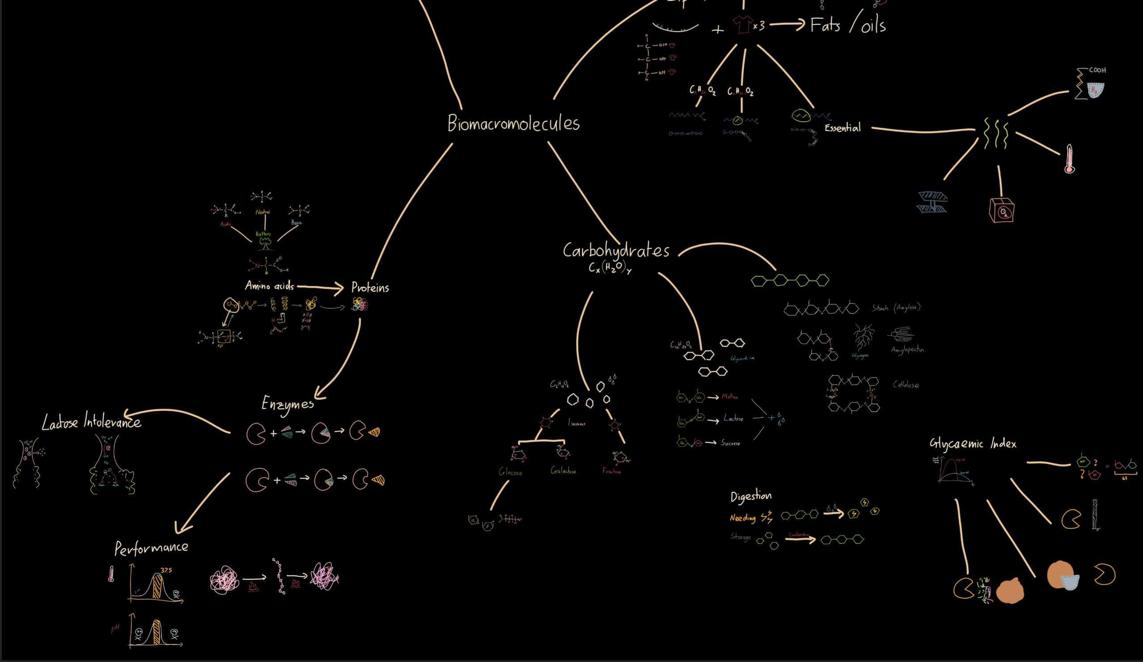
Regarding the work submitted by a student above, answer the questions below.
Which of these patterns are present? Select all that apply.
Lonely chunks
Unshaped
Over visualised
Spiderwebbing
Waterfalling
Ans: Over visualised
Waterfalling

Question 2

Regarding the work submitted by a student above, answer the questions below.
Over-visualised is:
Visuals are too large and take up excessive space on the map.
Visuals have been created for too many ideas and concepts, making the map hard to follow.
Visuals have been drawn in excessive detail, leading to wasted time.
The overall shape of the map has been overly prioritised, leading to wasted time.
Ans: Visuals have been created for too many ideas and concepts, making the map hard to follow.
Question 3
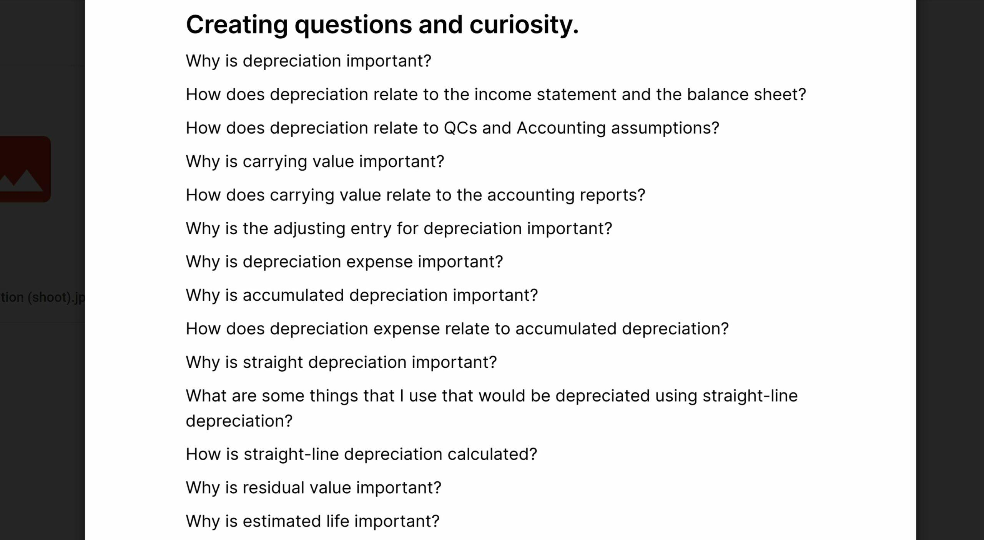
Regarding the work submitted by a student above, answer the questions below.
Which of the following are true regarding this learner's question quality?
There is lower order inquiry.
These questions are likely to promote simple question and answer.
These questions are likely to promote waterfalling.
There are no issues. The questions are high quality.
Ans: There are no issues. The questions are high quality.
Question 4

Regarding the work submitted by a student above, answer the questions below.
Regardless of the quality of their questions, there is a chance that chunk quality can be sabotaged by prechunking. This is when chunks are created before a deliberate inquiry process. Sometimes it is because some chunks feel obvious or due to framing bias. Why is prechunking potentially problematic?
Prechunking is always helpful as a springboard for hypothesising the initial chunk structure. There is no problem.
Prechunking can be helpful, but it can also bias the chunk structure formation towards one that is not cognitively optimal for our memory as some relationships are ignored.
Prechunking reduces the number of relationships we consider during inquiry, leading to waterfalling.
Prechunking bypasses the cognitive load associated with inquiry, which directly reduces the quality of learning.
Ans: Prechunking can be helpful, but it can also bias the chunk structure formation towards one that is not cognitively optimal for our memory as some relationships are ignored.
Learning notes
Baking Without Ingredients
Prechunking can be helpful by giving us a hypothetical chunk structure to start our evaluation process. However, it is crucial that the chunk structure is considered hypothetical and is actively challenged and refined during the inquiry process. Our pre-chunked structures will often not be the best structures to use, especially if they are based on common patterns of chunking that are repeated many times across similar topics. This problem was alluded to in the chunking for medicine sublesson in Ascent 1’s Aim examples lesson.
Because framing bias can be incredibly powerful, learners who struggle to break free from prechunked structures are advised to avoid prechunking altogether and form chunks only after deliberate inquiry.

Question 5
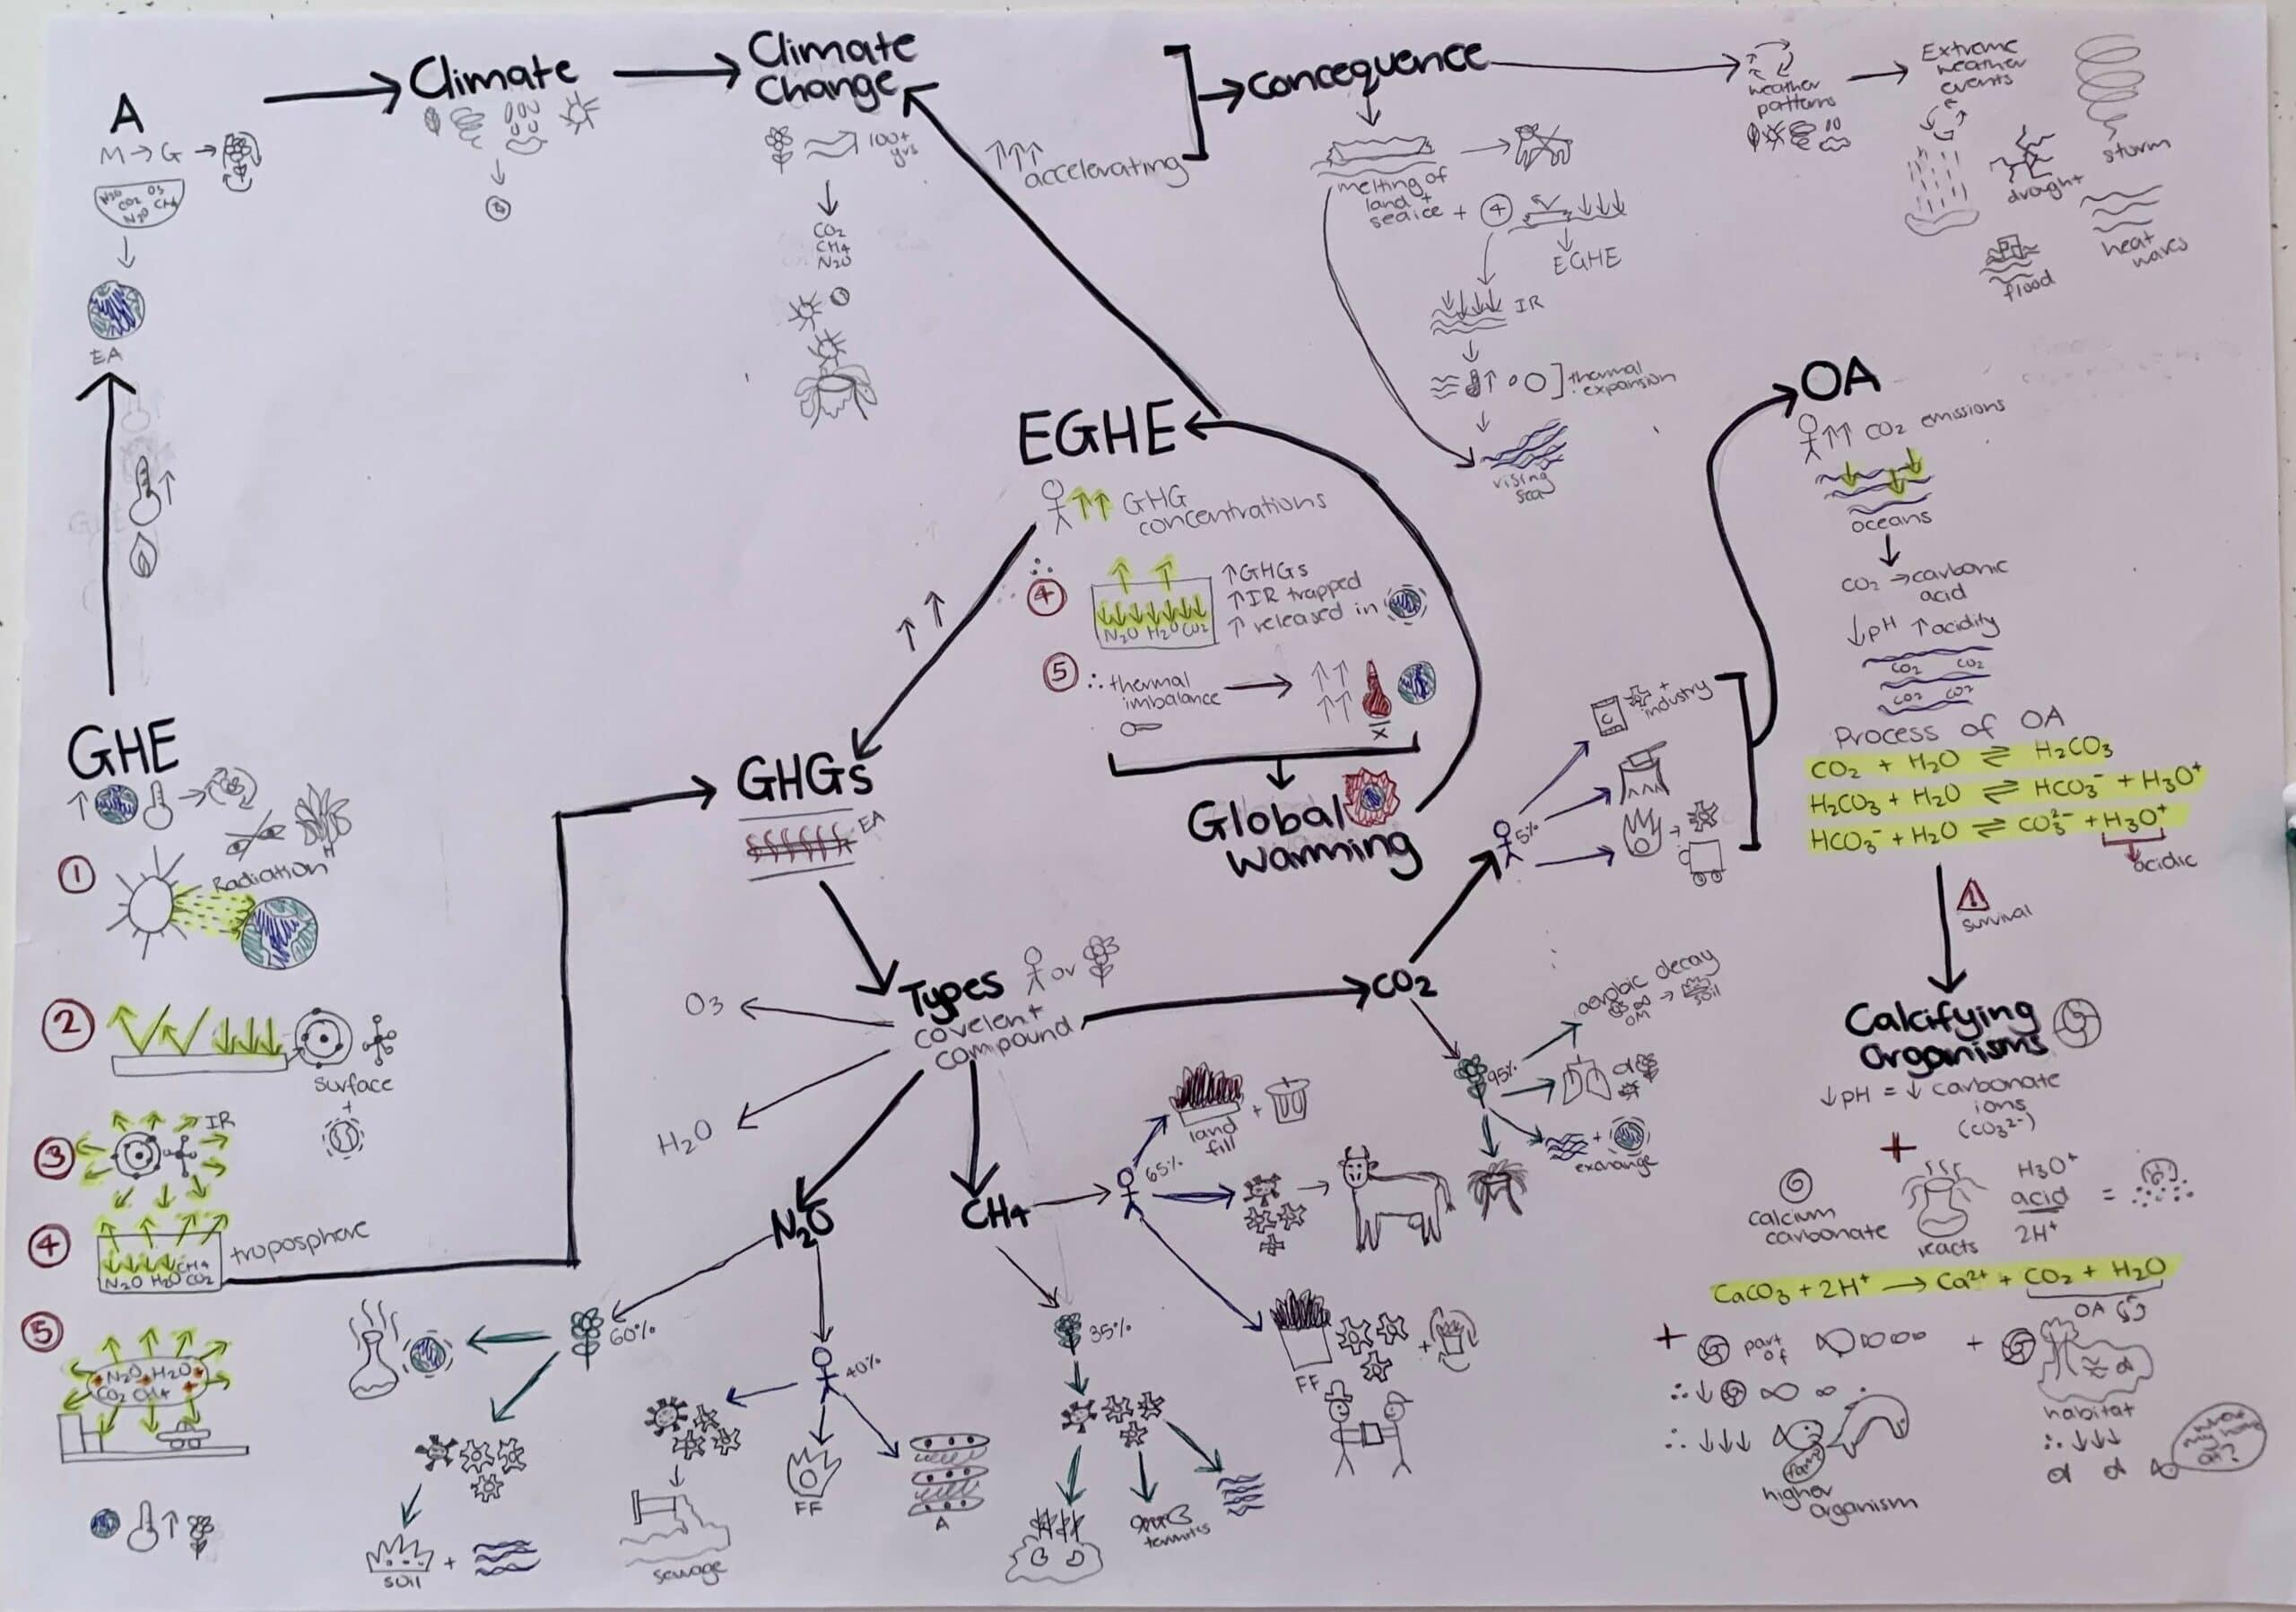
Regarding the work submitted by a student above, answer the questions below.
Which of these patterns are present? Select all that apply.
Over-visualised
Wheel and spokes
Too wordy
Waterfalling
Spiderwebbing
Hieroglyphics
Ans: Hieroglyphics
Learning notes
Hieroglyphics

Question 6
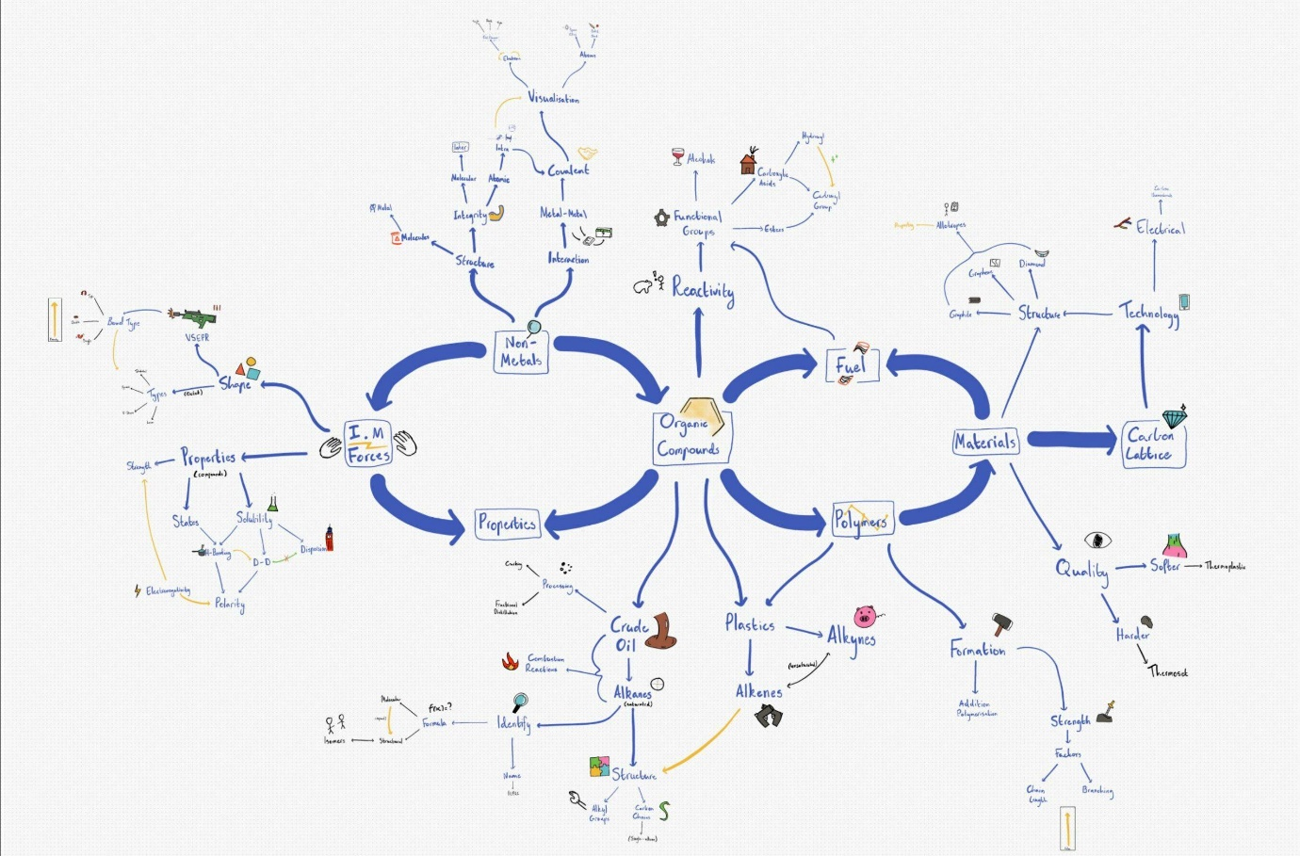
Regarding the work submitted by a student above, answer the questions below.
Which of these patterns are present? Select all that apply.
Segmental mapping
Detailed stripped
Insufficient chunking
Lines over arrows
Lower order inquiry
Spiderwebbing
Waterfalling
Ans: nsufficient chunking
Learning notes
The Final Chunkdown

Question 7
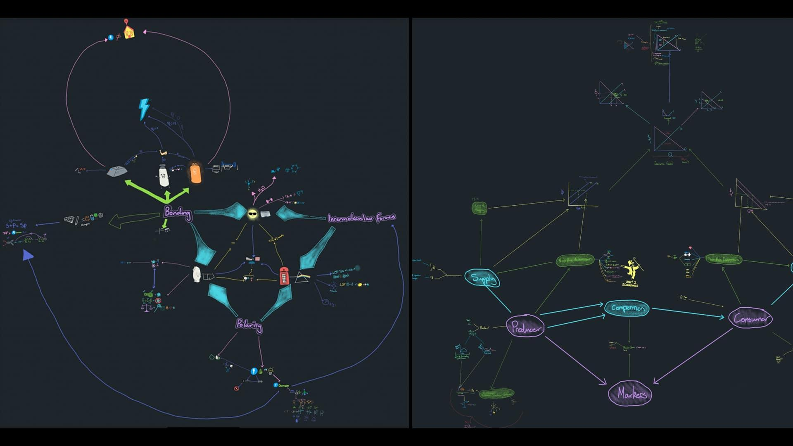
Regarding the work submitted by a student above, answer the questions below.
Which of these patterns are present? Select all that apply.
Overvisualized
Waterfall
Lonely chunks
Cracked glass
Insufficient chunking
No backbone
Ans: Cracked glass
Insufficient chunking

Question 8

Regarding the work submitted by a student above, answer the questions below.
Question 8.1
Cracked glass is:
Information represented in a line where each node of information on the line does not branch into further sub-chunks or information.
When there is no backbone in the mindmap.
When the learner breaks the 2:4 rule and has too many branches coming from a single chunk.
Chunks that are connected together through a web of concepts, rather than a clear backbone between major chunks.
Ans: Chunks that are connected together through a web of concepts, rather than a clear backbone between major chunks.

Question 8.2
Cracked glass occurs because:
There's insufficient chunking.
Learners dive into details too early without focusing on creating the backbone of the main ideas first.
Learners represent information in a hierarchy due to lack of high-quality chunking.
Learners are influenced by the way information is initially presented to them.
Ans: Learners dive into details too early without focusing on creating the backbone of the main ideas first.
Learning notes
A Cosmic Trio
When relational networks are formed with a cracked glass appearance, the relationships can be hard to remember due to their complexity. Often we see chunks connected to other chunks through their sub-concepts, rather than directly from chunk to chunk. Avoid this mistake by creating clear backbones between major chunks before committing to detailed information prematurely.
Cracked glass can also be a sign of segmental mapping whereby learners focus on fully developing just one chunk or concept to full depth before moving onto the next one. This is problematic as it does not consider how each chunk or concept is related to the big picture. Segmental mapping diminishes the quality of the chunk structure, adds potentially massive time inefficiency as the brain does not have big-picture relevance for the chunks it is trying to organise, and increases the likelihood of many other problems, including spiderwebbing.

Question 9
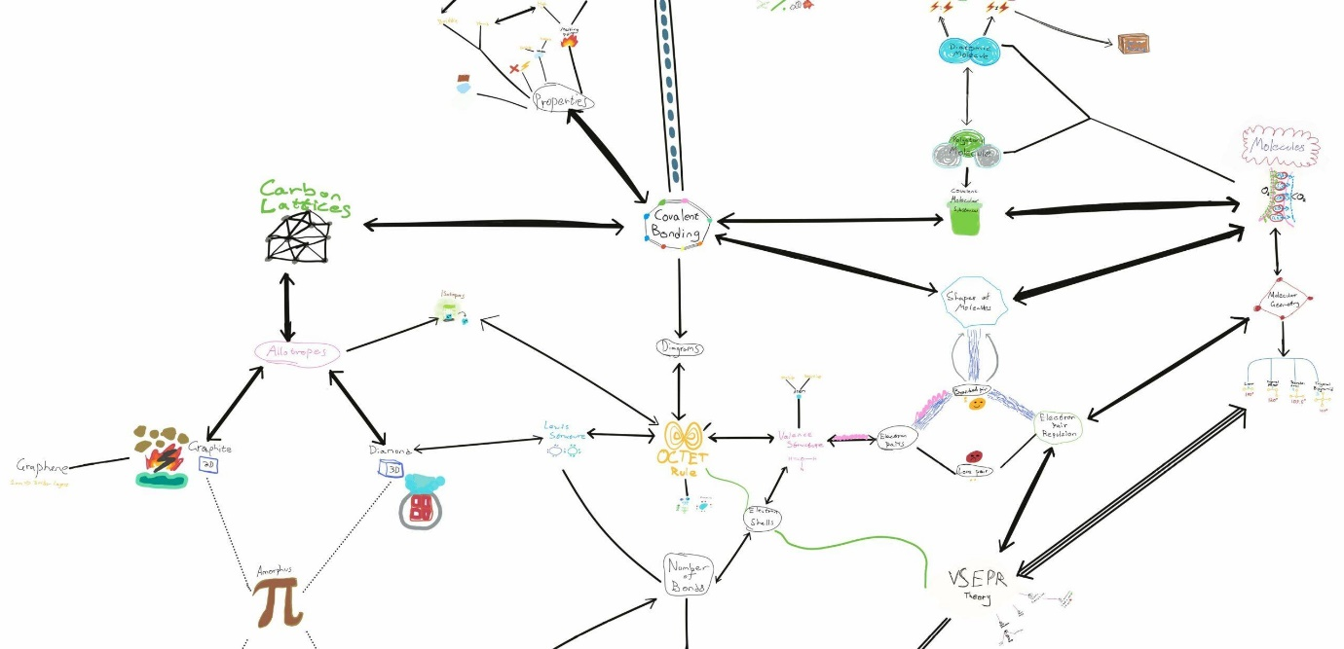
Regarding the work submitted by a student above, answer the questions below.
Which of these patterns are present? Select all that apply.
Importance checklist
Insufficient chunking
Waterfall
Spiderweb
Cracked glass
Segmented mapping
Ans: Importance checklist

Question 10

Regarding the work submitted by a student above, answer the questions below.
Question 10.1
Importance checklist is:
Only finding one reason for importance in response to an importance-based question.
Asking questions about the importance of a keyword in a narrow context.
Answering questions about a concepts' importance by considering multiple relationships to other concepts and evaluating the most relevant one.
Writing down the reason for importance under the question.
Ans: Only finding one reason for importance in response to an importance-based question.
Question 10.2
Importance checklist occurs because:
Each question was only able to generate one reason for importance.
Not enough relationships were generated to compare and evaluate to form chunks, despite the question having the potential for many relationships.
Writing the answer in a sentence under the question limits the potential relationships being considered.
Too many answers to a single question is overwhelming, leading to a web of arrows connecting multiple ideas.
Ans: Not enough relationships were generated to compare and evaluate to form chunks, despite the question having the potential for many relationships.
Learning notes
Interchunkecular Forces
Importance checklisting is similar to simple question and answer in that they both obstruct the benefit of the inquiry process. With importance checklists, the importance-based questions (while high quality) are not explored beyond a single reason for importance. As a result, only one relationship is formed. Avoid this by finding multiple reasons for importance and evaluating how multiple concepts are similar in different ways. These similarities allow us to form chunks and different kinds of similarities help us identify alternative chunks.
In many cases, all it takes is to rearrange a few concepts into an alternative chunk to be able to see an entirely new perspective to the topic and a potentially drastically different chunk structure.

Progress Check
Procrastination
On a scale of 1 to 10, how well do you manage procrastination?
1 is very poorly (you significantly struggle with procrastination). 10 is very well (you do not have problems with procrastination at all).
Learning
On a scale of 1 to 10, how efficient would you rate your learning ability?
1 is not at all efficient. 10 is very efficient (able to cover large volumes with high depth and retention in a short time).
Confidence
On a scale of 1 to 10, how confident are you to overcome learning challenges and reach your learning goals?
1 is extremely unconfident. 10 is extremely confident.
Learning
If you have had an assessment (e.g. an exam) in the last four weeks, what results did you achieve?
96 to 100%91 to 95%86 to 90%81 to 85%76 to 80%71 to 75%65 to 70%60 to 64%Below 60%No recent assessment
Compared to your baseline performance, how would you rate your most recent learning performance?
Significantly worse
Worse
Similar
Improved
Significantly improved
Baseline is considered your normal level before joining our program.
Your experience
Have you noticed any other benefits or improvements that were not mentioned in the questions above?
For example, improvements in mood, sleep, career development, free time, well-being, or employability.
This is optional.

